Software Requirement Specifications Document

caXchange – ScenPro, Inc.
Ekagra, AOT

DOCUMENT CHANGE HISTORY
Version Number | Date | Contributor | Description
1.0 | 07/07/06 | Charles Griffin | Initial Draft
1.0 | 07/27/06 | Charles Griffin | Added additional requirements based on feed back from Hub SIG review and added Use Case Mappings
1.0 | 08/24/06 | Charles Griffin | Added additional requirements and made formatting modifications based on feedback from Christo and the Booz Allen Hamilton team
1.0 | 9/08/06 | Smita Hastak | Added iteration numbers to each of the requirement as requested by BAH and Christo A
1.1 | 2/20/07 | Charles Griffin; Smita Hastak | Added Requirements from the CTMSI Project – sections 1.1; 1.1.4; 3.1; 3.1.6;
1.2 | 9/26/07 | Kalpesh S. Patel | Modified document for phase II requirements
1.2 | 10/3/2007 | Michael Holck | Reformatted document and revised content
1.2 | 10/15/2007 | Kalpesh S. Patel | Modified to accommodate new template requirements
1.2 | 10/31/2007 | Eric Chen | Updated HL7 v3 data type requirements
1.3 | 12/10/2007 | Michael Holck | Updated to address comments from John Koisch
1.4 | 12/12/2007 | Kalpesh S. Patel | Modified to include appropriate release information
1.5 | 12/12/2007 | Jennifer Brush | Moved ‘future’ requirements to future requirements sections by application.
1.6 | 1/8/2008 | Bill McCurry | Added requirements for HL7 v3 data types, reformatted tables for consistency, and credited America On Top.

Updated January 7, 2008

TABLE OF CONTENTS
1 Background/Summary 4
2 Introduction 5
2.1 Document Overview 5
2.1.1 SCOPE 5
2.2 Related documents 8
2.2.1 Application System Diagram 8
2.3 Release Overview 9
2.4 Definitions 9
3 caXchange requirements 10
3.1.1 Constraints 10
3.1.2 Qualification Provision 11
3.1.3 Assumptions 11
3.1.4 Dependencies 11
3.1.5 Security 12
3.1.6 Environment 12
4 Application Functional Requirements 13
4.1 caxchange solution REQUIREMENTS 13
4.1.1 caXchange Component Requirements 14
4.1.2 Cancer Center Hub Client 17
4.1.3 CTOM Data Service 19
4.1.4 caXchange Administrator 20
4.1.5 Documentation Artifact 21
4.1.6 CTODS Lab Viewer 22
4.2 FUTURE PHASES 24
5 Application Quality Requirements 29
5.1 Database schema 33
6 Requirement Change Management 35
7 Glossary 35
8 Appendix A – Use Case ID/Name Mapping 36

Background/Summary
The overall goal of this project is to build a hub system that can be adapted and extended to multiple data formats and whose value and usability can be applied in one or more cancer centers. As the caBIG program is the primary sponsor, all work performed for this project must be done in compliance with the caBIG principles of open source, open development, open access, and federation. Software that is used and/or developed in the context of this project must be caBIG™ compatible at the silver level
(https://cabig.nci.nih.gov/guidelines_documentation/caBIGCompatGuideRev2_final.pdf)
and be made available to the community through resources provided by the General Contractor. The key roles in the project are defined in Table 1.
Table 1 Key caXchange Project Roles
Role | Name | Comments
Project Sponsor | caBIG
Reviewer | caBIG Architecture Workspace | Will review and provide guidance of architecture artifacts
Reviewer | CCTS Architecture Team | Will provide requirements
User | NCICB | Responsible for hosting the hub
Developer | ScenPro, Ekagra Software Technologies, America On Top Corp. | Joint Development Team

The caXchange Solution consists of multiple distributed components. The components related to the caXchange and their respective locations where they will be hosted are provided in Table 2.
Table 2 caXchange Components
Component | Hosting Site | Comments
caXchange | NCICB | The hub and all auditing and logging
Cancer Center Hub Client | NCICB | The original hub client was used at Lombardi Cancer Center but the current project has no official adopter
Clinical Trial Object Model Data Service | NCICB | The web service to receive lab data from the hub and persist to CTOM
CTOM Lab Viewer | NCICB | The application to view all lab data persisted in CTOM and to interact with other CCTS systems

Introduction

Document Overview
This Software Requirements Specification (SRS) document captures the software requirements for only the software components of the caXchange version 1.0. The overall goal of this project is to build a hub system that can adapt and extend data to multiple formats and whose value and usability can be pilot tested in one or more cancer centers.

SCOPE
The caXchange version 1.0.project involves both technical and non-technical efforts that are divided amongst the groups defined in the sub-sections in Section 1. This document will only address efforts that are directly related to the caXchange component of the entire solution. The caXchange is defined as the software component that is primarily responsible for receiving input from various external systems, routing the input to various services that are hosted on the hub, and eventually routing the output of those services to external systems.
The scope of this effort was extended to support the CTMS Interoperability Project. caXchange (Lab Integration Hub) is now a more generic platform for data exchange and services and was leveraged in the CTMS I project. The scope now includes building a CTOM lab viewer application to allow the users to view and query the lab data that was persisted in the CTOM database as well as send data to other CCTS systems.
The scope of caXchange version 1.0 effort includes continued support for CCTS (originally CTMSi). Moreover it will allow for the necessary extensibility to meet the long-term objectives of having caXchange function as an enterprise interface engine.
caXchange Phase II (caXchange version 1.0) will provide additional functionality to the community. Specifically, it will include enhancements that focus on:
- The ability to convert HL7v2 to HL7v3 messages
- Enhancing the Lab Viewer in terms of robustness and interoperability with other caXchange and CTMS application modules as demonstrated in the CTMSi project.
- Supporting SOA architecture to provide additional functionality currently not provided by caGRID including routing, logging, message handshaking, etc. as specifically defined by the CCTS Architecture group and in compliance with the CCTS Technical Governance framework defined by the CCTS team.
This document does not address system or user related requirements that are not directly related to the caXchange, i.e. engaging the Lab Hub SIG, object modeling efforts, etc.

Cancer Center Hub Client
The Cancer Center Hub Client is a software component that will reside on a remote machine at a cancer center. The Cancer Center Hub Client is responsible for sending patient laboratory data to the caXchange hub in HL7v3 format. In this phase we will develop a GUI for the client to make it easier for the end user to use.

The caXchange Service Hub
The caXchange Service Hub is defined as the software component that is primarily responsible for receiving input from various external systems, routing the input to various services that are hosted on the hub, and eventually routing the output of those services to external systems. The Hub will also perform logging and auditing of all messages that pass through the hub.
For this effort the caXchange Service Hub will reside on the NCICB servers and will be responsible for receiving patient laboratory data in HL7v3 format for CT Laboratory Observation Periodic Report messages, and routing the messages to the CTOM data service. It will also route additional data and messages from CCTS applications to other CCTS applications in support of the CCTS interoperability requirements.

Clinical Trial Object Model (CTOM) Data Service
The CTOM Data Service is a software component residing external to the caXchange hub. This service will be able to receive HL7v3 CT Laboratory Observation Periodic Report messages and persist the domain related data contained in the message into an instance of the CTOM database. This software component will reside on the NCICB servers but will be external to the caXchange.
The CTOM data service (which persists the laboratory data into the CTOM Database) is just one of many destinations (Endpoints) that the HL7v3 Laboratory Observation Periodic Report message can be routed to. It is expected that data will be routed to additional Endpoints as they are identified in future releases.
In addition to the HL7v3 Laboratory Observation Periodic Report message, the CTOM Data Service can also receive the C3PR v 2.0 Registration message. The participant data from this message will be persisted into the CTOM database and will be used to match up the identifier with the lab results that are also persisted in CTOM.

CTOM Lab Viewer
The CTOM Lab Viewer is a web based application developed by leveraging the SDK generated APIs of the Lab Domain UML model from the core caXchange effort. Building of this application adds substantial enhancement to caXchange and provides the complete the end to end caXchange solution. In the original caXchange v 0.5, laboratory data from a cancer center was being transformed, routed, and persisted into the CTOM database, but there was no visual and user friendly GUI tool to view the laboratory data that got stored in CTOM database. Based on the use cases identified by the SMEs of the CTMS Interoperability project, a new requirement was identified that made the viewing of lab data from CTOM a critical piece of the CTMS interoperability project.
The CTOM Lab Viewer allows users to view laboratory activities records that are stored in the CTOM database. Users will be allowed to search the laboratory activity records by Patient Id, Study Id, Lab Start Date, and Lab End Date. When the search results are displayed, numeric results that are outside the high and low reference ranges of the lab tests will be highlighted to alert the user. This visual alert/trigger will allow the user to focus in and act on those specific lab test results such as sending them to caAERS as candidate adverse events.
Additionally, the CTOM Lab viewer will allow users to send lab data to the local CDMS application (C3D). The functionality to select which labs should be loaded into the CDMS will be provided in the CTOM Lab Viewer interface.

Vision
Clinical laboratory systems in cancer centers often (but not always) have an interface that supplies laboratory data in the form of HL7v2.x messages. It is also possible that some clinical laboratory systems can only supply data in comma delimited or other file formats, or that the local healthcare system’s information services organization chooses to provide information in such a manner. Various clinical trials management systems likewise may accept data in multiple formats. The program’s interest is specifically in delivering clinical research laboratory data using the HL7v3 CT Laboratory Observation Periodic Report message, based on the CDISC lab standard, but it is anticipated that other output formats will be needed. Currently, cancer centers desiring a laboratory data feed are faced with an expensive project to custom-build an interface between the two systems. Owing to the heterogeneous nature of laboratory systems, it is not expected that the local implementation effort at cancer centers can be reduced to zero, but minimizing local development work is highly desirable.
This project will focus on the development of an open-source, caBIG™ compatible solution to support the exchange of laboratory data collected during a clinical trial. The resulting solution must be stand alone and Silver level compatible.

Identification
The entire solution, including the items not addressed in this document will be identified as the “caXchange.” The following sub-sections identify the components that are addressed in this document.

Software
Table 3 Project Software
Title | Abbreviation | Release #
caXchange | CAXCHANGE | 1.0
Cancer Center Hub Client | CCHC | 1.0
Clinical Trial Object Data System Data Service | CTODS Data Services | 1.0
Clinical Trial Object Data System Laboratory Data Viewer | CTODS Lab Viewer | 1.0

Documentation
Table 4 Project Documentation
Title | Abbreviation | Release #
Technical Architecture Guide | N/A | 1.0
Installation Guide | Install Guide | 1.0
Administrative Guide | Admin Guide | 1.0

It is important to note that providing documentation for any of the COTS or Open Source products utilized in caXchange is not in the scope of this release. For obtaining documentation on these products, it is suggested that users or developers go to the website hosting the particular product they are interested in to retrieve the documentation.

Related documents
Table 5 Related Documents
Document Name | Version | Location
caXchange Use Case Specification and Realization Document | 1.0 | https://gforge.nci.nih.gov/plugins/scmcvs/cvsweb.php/caxchange/Deliverables/Use%20Case%20Specification%20and%20Realization%20Documents%20(Task%202.1).rtf?cvsroot=caxchange
caXchange Design Document | 1.0 | https://gforge.nci.nih.gov/plugins/scmcvs/cvsweb.php/caxchange/Deliverables/Draft%20Design%20Document%20(Task%202.4.1).doc?cvsroot=caxchange
caXchange Technical Architecture Guide | Future

Application System Diagram
The diagram below depicts the various components of the caXchange effort along with some of the external systems caXchange will interact with.

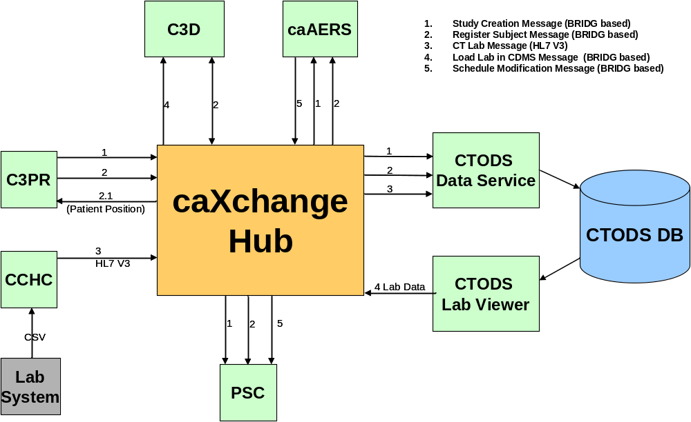

Release Overview
Table 6 Project Release Information
Release | Date Released | Version comments
0.5 | 2/20/2007 | Released as Lab Hub
1.0 | 2/14/2008 | Will be a part of CCTS 1.0 release
Future | TBD | Additional capability developed after CCTS 1.0

Definitions
Developers and Adopters are expected to clearly understand on the definitions and agree upon the ranking of the definitions used with any given requirement.
MUST - This word means that the definition is an absolute requirement of the specification.
MUST NOT - This phrase means that the definition is an absolute prohibition of the specification.
WILL - This word means that the definition is an absolute future requirement of the specification.
WILL NOT - This phrase mean that the definition is an absolute future prohibition of the specification.
SHOULD - This word means that there may exist valid reasons in particular circumstances to ignore a particular item, but the full implications must be understood and carefully weighed before choosing a different course.
SHOULD NOT - This phrase means that there may exist valid reasons in particular circumstances when the particular behavior is acceptable or even useful, but the full implications should be understood and the case carefully weighed before implementing any behavior described with this label.
MAY - This word means that a requirement is truly optional. The developer may choose to include the item based on the needs of their design.

caXchange requirements
There user/system requirements are derived from original Laboratory Information Integration Hub Statement of Work, enhancement requirements for CTMSi, the new SOW for Phase II of caXchange as well as requirement gathering meetings with project stakeholders. The list of stakeholders consists of:
- CTMS Study Conduct SIG
- CCTS architecture team
- NCICB Product Management
Additional requirements will be gathered during the review period of the draft of this document as well as during the initial design phase of the various caXchange components.
The requirements can be grouped into two major categories: (1) Software and (2) Documentation. The Software category includes the requirements for each of the components being developed by the caXchange technical team that comprise the end to end technical solution. The Documentation category includes a description of the various documentation artifacts that are expected to be produced by the caXchange team during the version 1.0 release.

Constraints
The constraints that apply to the caXchange software engineering options are provided below:
- All software components utilized in this solution must be open source and freely distributable.
- The software components utilized in this solution should adhere to the existing technology stack of the environments they will be deployed in.
- The solution must meet the HIPAA privacy standards.
- The solution must adhere to technical and operational principles of the caBIG program.

Qualification Provision
This section defines a set of qualification methods and shall specify for each of the requirements defined and the method(s) to be used to ensure that the requirement has been met.
Table 7 Qualification Requirements
Qualification Method | Description | Requirements
Demonstration | The operation of the system or component that relies on observable functional operation not requiring the use of instrumentation, special test equipment, or subsequent analysis.
Test | The operation of the system or component using instrumentation or other special test equipment to collect data for later analysis.
Analysis | The processing of accumulated data obtained from other qualification methods. Examples are reduction, interpretation, or extrapolation of test results.
Inspection | The visual examination of code, documentation, etc.

Assumptions
The assumptions of the caXchange and its related software components are:
- The NCICB hosted components will be deployed in the shared production NCICB environment.
- The project components will adhere as closely as possible to the published NCICB Future Technology Stack
- The caCORE and caBIG products utilized in this solution are expected to perform their proposed functionality. If there are any product defects, they will be fixed by the respective product team and not the caXchange development team.
- If the appropriate versions of the proposed products that are expected to be used in this solution are not available, a work around must be implemented by the caXchange team, however, the caXchange team will not write replacements for those products.
- ServiceMix 3.1.1 (or 3.1.2) will be used for this caXchange release

Dependencies
The dependencies of the caXchange and its related software components are described below:
- The caAdapter product will provide the APIs to map and transform comma delimited patent lab data to an HL7v3 format
- The caAdapter product will provide the APIs to map and transform HL7v2 patent lab data to an HL7v3 format
- The C3PR grid service provided by C3PR R2 will be utilized to formulate the HL7v3 messages with additional identifier information
- The CTOM lab model will be used for generation of the APIs used by the CTOM Lab Viewer
- The BRIDG Clinical Analysis Models (CAM) will be used to generate the BRIDG based messaging objects

Security
In the prior release of caXchange the NCICB CSM product for authentication and authorization was utilized. In this release the authentication and authorization will be replaced with Grid Authentication and authorization technology to accept a user’s grid credentials.
The webSSO implementation (that is based on Grid authentication and authorization) that is currently being developed by caGrid team will be utilized for the CCTS project and caXchange will integrate for user level authentication and authorization.

Environment
All caBIG projects must be platform and database-independent applications. In the case of caXchange, it means it should be possible to run it on any operating system and it should support any database. Table 8 below details the environment to be used for testing caXchange.
Table 8 System Environment
Operating system | Linux
Database | Oracle 9i
Browser | FireFox 2.x and above
Browser | Internet Explorer 6 and above
Java | 1.5.x
Container | ServiceMix 3.1.2 and Tomcat 5.0.28

Application Functional Requirements

caxchange solution REQUIREMENTS
The following sections describe the requirements for the end to end technical solution. Table 9 provides the high level requirements for each of the software components. Each requirement is further elaborated upon in the corresponding requirement categories in following sections. Where possible, both the use case model and data describing each of the requirements are provided. These high level requirements include the requirements for all components of caXchange including the CCHC and the Lab Viewer.
* Note: The Use Case ID columns in the Requirement tables in the subsequent sections are populated with Use Case Names for readability. Enterprise Architect assigns a GUID to each Use Case which is unique but lengthy and difficult to use. A table mapping the Use Case names and GUID can be found in Appendix A.
Table 9 caXchange High Level Requirements
Req ID | Requirement Type | Requirement Details | Release # | Test Case ID
1.0 | System | The system must provide the ability to receive, transform, and route CT Laboratory Observation Periodic Report in HL7v3 format to various external systems. | 1.0
2.0 | System | The system must provide the ability for Cancer Centers to send patient laboratory data to the caXchange. The patient lab data will be in a caAdapter required .csv format or HL7v2. The solution should not require the Cancer Center to perform any elaborate programming. | 1.0
3.0 | System | The system must provide the ability to receive the HL7 v3 CT Laboratory Observation Periodic Report message and a C3PR Registration Message from a service external to the caXchange and persist the contained domain data in the payload into the CTOM database | 1.0
4.0 | System | The system must provide the ability to monitor the caXchange activities and perform administrative functions on the caXchange | 1.0
5.0 | Non Functional | The system must provide Architectural and User documentation for the technical components developed by the caXchange technical team. | 1.0
6.0 | System | The system must provide the ability to allow users to view lab data stored within the CTODS database and send the data to external systems to be loaded, | 1.0
7.0 | Non Functional | The system must be upgraded from FUSE to ServiceMix and set up for clustering for high availability and scalability solution | 1.0
8.0 | System | The system will allow communication of non-grid applications on caXchange ESB to Grid Services or Grid Clients | 1.0
9.0 | System | The system must build a message exchange framework based on the BRIDG  model to implement the wire-format for CCTS messages. | 1.0
10.0 | System | The system must be enhanced to automate custom workflow by routing rules in the database to provide routing to multiple services and support itinerary based routing. | 1.0

caXchange Component Requirements
This section describes the requirements for the caXchange component of the caXchange Solution. The requirements have been captured in the form of a use case model (shown in Figure 1) and documented in Table 10.
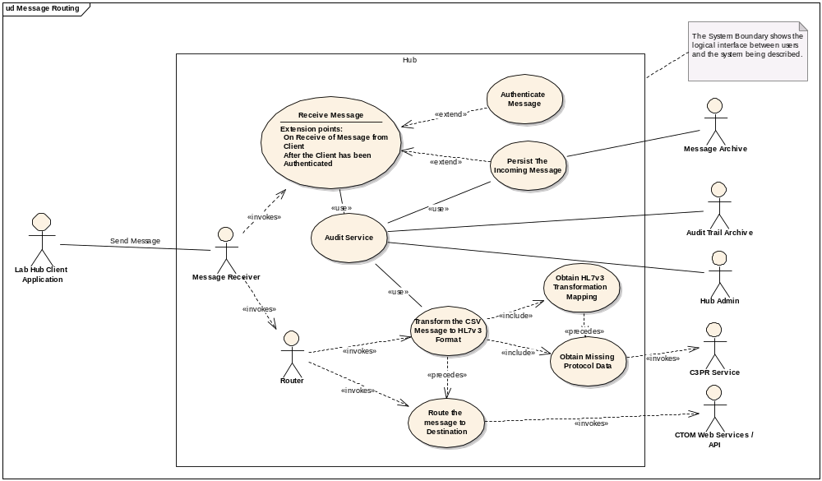
Figure 1 caXchange Component Use Case

Table 10 caXchange Component Requirements
Req ID | Requirement Type | Requirement Details | Release # | Use Case ID | Test Case ID
Message Receipt
1.1 | System | The system must accept the grid credential of the authenticated user from the grid client or grid service. | 1.0 | Authenticate Message
1.2 | System | The system must perform a check to ensure that the sender of each message is authorized to perform a defined workflow on the caXchange. | 1.0 | Authenticate Message
1.3 | System | The system must send an Acknowledgement Response to the sender indicating the message was successfully received.  A successful audit message must be logged. | 1.0 | Receive Message,  Audit Service
1.4 | System | If an error occurred or user authorization failed, then an Error Response must be returned to the sender indicating the reason why the request failed.  In case of failure, an error audit message must be logged. | 1.0 | Receive Message,  Audit Service
1.5 | System | After a message is received, the system must normalize and route it to the appropriate service on the caXchange. The routing will be done based on metadata in the received message. | 1.0 | Receive Message,  Route the Message to Destination
Routing
1.6 | System | The system must provide the ability to route an incoming message from the Cancer Center Hub client to the CTODS persistence Service. | 1.0 | Route the Message to Destination
1.7 | System | The system will provide the ability to guarantee message delivery to services on the caXchange even in the event of a server shut down | 1.0 | Route the Message to Destination
1.8 | System | The system must support the concept of a normalized message. A normalized message meaning a common message interface or construct that the caXchange can route to services deployed on the caXchange. | 1.0 | Route the Message to Destination
Audit and Error Logs
1.9 | System | The system must provide the ability to view the audit/log data repository for audits and logs in a specified period of time | 1.0 | Audit Service,  (Functionality provided by the CLM product)
1.10 | System | The system will ensure that each Cancer Center is able to view their respective audits/logs. | 1.0 | Audit Service
1.11 | System | The system will provide a service (Audit/Log Service) on the caXchange that audits messages exchange occurring inside the caXchange | 1.0 | Audit Service
1.12 | System | The Audit/Log Service will persist the audit/log data received in the message in a common audit /log data store. | 1.0 | Audit Service
1.13 | System | The system must audit requests sent to any service on the ESB without the service actually pushing messages to the audit  service. | 1.0 | Audit Service
1.14 | System | The system must ensure that the retrieval of the credential information from the message is possible | 1.0 | Audit Service  (All of the components on the hub will be enhanced to be able to retrieve user identity from incoming messages)

Upgrade to ServiceMix and Scalability Enhancements
This section describes the requirements for the upgrade of the underlying Enterprise Service Bus framework for scalability.
Table 11 Upgrade to ServiceMix and Scalability Enhancements Requirements
Req ID | Requirement Type | Requirement Details | Release # | Use Case ID | Test Case ID
7.1 | System | Installation and configuration of the ServiceMix 3.1.2 must be performed | 1.0
7.2 | System | HTTP Binding component must be migrated to ServiceMix 3.1.2 | 1.0
7.3 | System | JSR181 Service Engine must be migrated to ServiceMix 3.1.2 | 1.0
7.4 | System | Routing and Workflow webservice must be migrated or upgraded | 1.0
7.5 | System | The system must accept request from a caGrid authenticated user | 1.0
7.6 | System | The system must integrate with grid delegation service for authorization | 1.0
7.7 | System | Audit Service must be migrated to ServiceMix 3.1.2 | 1.0
7.8 | System | CTOM WebService Client must be migrated to ServiceMix 3.1.2 | 1.0

Integration of Non-grid applications to Grid Services or Grid Clients
This section details the requirements for integration of Non-grid applications on the hub to communicate with Grid services or clients.
Table 12 Integration of Non-grid Applications to Grid Services or Grid Clients Requirements
Req ID | Requirement Type | Requirement Details | Release # | Use Case ID | Test Case ID
8.1 | System | The system must develop Inbound Grid Binding Component that will allow Grid Services or Grid Clients to communicate with non-Grid applications | 1.0
8.2 | System | A framework to support the exposure of caGrid based services that provision HL-7 v3 data types via caGrid, leveraging HL7 JavaSIG’s implementation must be developed | 1.0
8.2.1 | System | The system must implement the framework allowing to use the HL7 v3 data types, which are most common used at CAM ITS implementation messages, in both inbound and outbound grid services. | 1.0
8.2.1.1 | System | The system must support II, CD HL7 v3 data types. | 1.0

Cancer Center Hub Client
This section describes the requirements for the Cancer Center Hub Client component of the caXchange Solution. The requirements have been captured in the form of a use case model (shown in Figure 2).
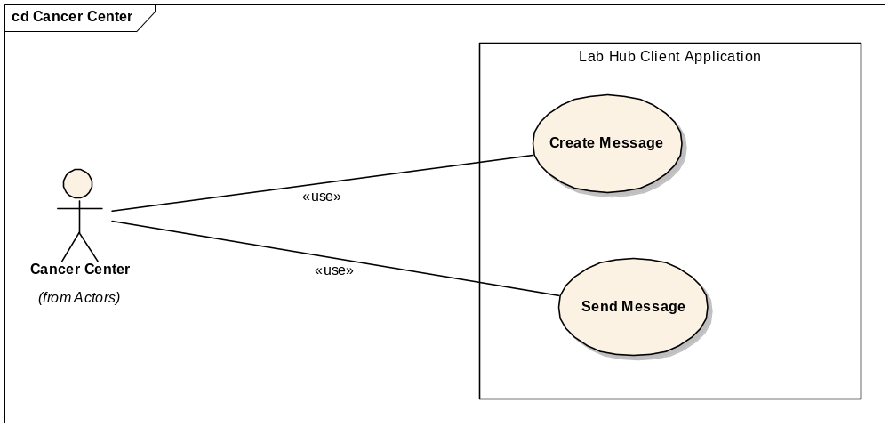
Figure 2 Cancer Center Hub Client Use Case
Table 13 Cancer Center Hub Client Requirements
Req ID | Requirement Type | Requirement Details | Release # | Use Case ID | Test Case ID
2.1 | User | The system should minimize the local development work to send laboratory data to the caXchange | 1.0 | Create Message
2.2 | System | The CCHC must be able to retrieve laboratory data in a specified format and create a message that can be sent to the caXchange. | 1.0 | Create Message
2.3 | System | The CCHC must retrieve files containing the laboratory data in a .csv format from a user defined directory | 1.0 | Create Message
2.4 | System | The CCHC must poll a user defined directory repeatedly for a laboratory data file with a user specified amount of time between each polling | 1.0 | Create Message
2.5 | System | The CCHC must either delete, rename, or move a file after it is sent to the caXchange so it will not be resent to the caXchange. | 1.0 | Send Message
2.6 | System | The CCHC must be able to send the laboratory data message to the caXchange | 1.0 | Send Message
2.7 | System | The CCHC must be able to log successful and unsuccessful attempts to send messages to the caXchange | 1.0 | Send Message
2.8 | System | Security will be placed on the directory that the CCHC will poll for the .csv files. The security will allow only authorized users to put .csv files in the directory. | 1.0 | Create Message
2.9 | System | The CCHC must be able to transform the source data into an HL7v3 format and send to the caXchange | 1.0 | Create Message

CTOM Data Service
This section describes the requirements for the CTOM Data Service component of the caXchange Solution. The requirements have been captured in the form of a use case model (shown in Figure 3).
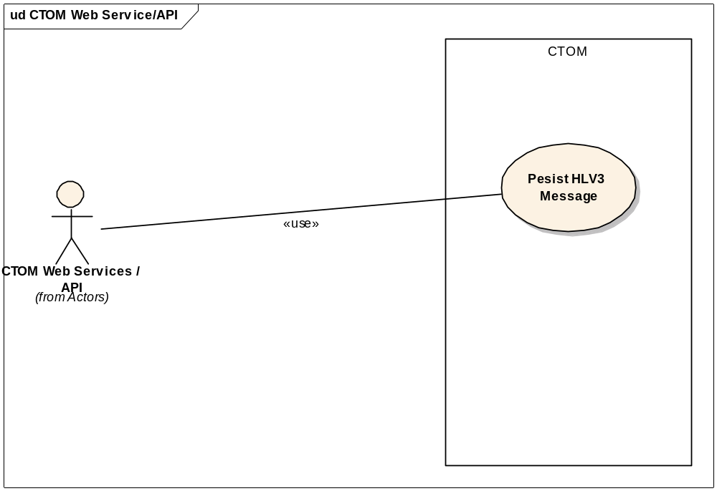
Figure 3 CTOM Data Service Use Case
Table 14 CTOM Data Service Requirements
Req ID | Requirement Type | Requirement Details | Release # | Use Case ID | Test Case ID
3.1 | System | The CTOM Data Service must receive messages in the HL7v3 CT Laboratory Observation Periodic Report format | 0.5 | Persist HL7v3 Message
3.2 | System | The CTOM Data Service must perform authentication and authorization security checks to ensure the sender is a recognized client and is authorized to send data to the CTOM data service | 1.0 | Persist HL7v3 Message
3.3 | System | The CTOM Data Service must persist the data from HL7v3 CT Laboratory Observation Periodic Report message to the CTOM database | 1.0 | Persist HL7v3 Message
3.4 | System | The CTOM Data Service must parse the HL7 v3 CT Laboratory Observation Periodic Report messages and persist only the domain related data into the CTOM database | 1.0 | Persist HL7v3 Message
3.5 | System | The CTOM Data Service must parse the C3PR Registration message and persist data pertaining to a participant within the CTOM database | 1.0

caXchange Administrator
This section describes the requirements for the system requirements to support the Information Hub Administrator. The requirements have been captured in the form of a use case model (shown in Figure 4).
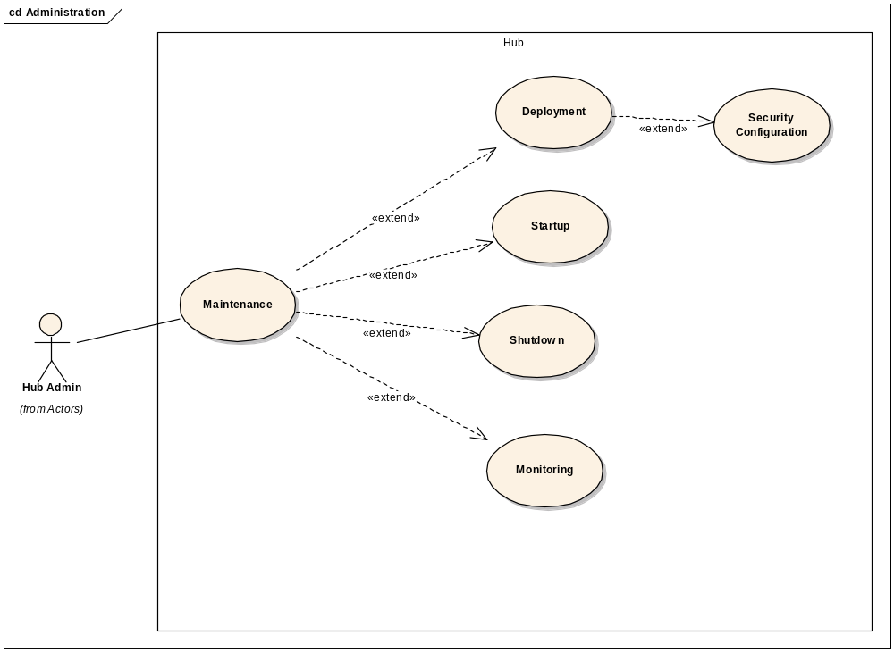
Figure 4 caXchange Administrator Use Case
Table 15 caXchange Administrator Requirements
Req ID | Requirement Type | Requirement Details | Release # | Use Case ID | Test Case ID
4.1 | System | The caXchange must provide the ability to deploy new services on the caXchange without disrupting processing of existing services and messages | 1.0 | Deployment
4.2 | System | The caXchange must provide the ability to uninstall new services on the caXchange without disrupting processing of existing services and messages | 1.0 | Deployment
4.3 | System | The caXchange must provide the caXchange Administrator the ability to shutdown the caXchange | 1.0 | Shutdown

Documentation Artifact
This section describes the requirements for the system documentation artifacts that the caXchange team must generate as part of release version 1.0.
Table 16 Documentation Artifacts
Req ID | Requirement Type | Requirement Details | Release # | Use Case ID | Test Case ID
5.1 | User | Technical Architecture Guide | 1.0
5.2 | User | Installation Guide | 1.0
5.3 | User | Administrative Guide | 1.0
5.4 | User | CCHC SOP – An SOP must be written that specifies security configuration and procedures for CCHC. | 1.0

CTODS Lab Viewer
This section describes the requirements for the CTODS Lab Viewer. These requirements were generated as part of the CCTS Project.
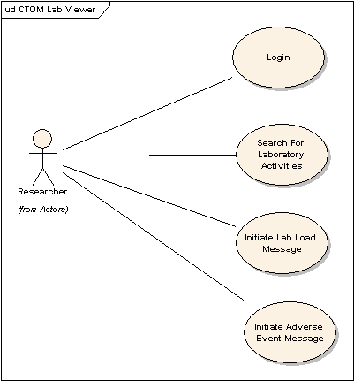
Figure 5 CTODS Lab Viewer Use Case
Table 17 CTODS Lab Viewer Requirements
Req ID | Requirement Type | Requirement Details | Release # | Use Case ID | Test Case ID
6.1 | User | Users must be provided with a graphical user interface application to query and view the patient lab data from the CTODS database via the Lab domain APIs | 1.0
6.2 | User | Users must be able to login with a valid username and password. | 1.0
6.3 | User | Users must be able to search for lab activities by patient identifier, study id, begin lab activity date, and end lab activity date. | 1.0
6.4 | User | Users must be able to view the lab activity search results. | 1.0
6.5 | User | Users must be able to select one or more lab activities from the search result and initiate a process to load them into an external CTMS system. | 1.0
6.6 | User | Users must be able to initiate a process that flags a lab activity result as an Adverse Event and sends that lab activity to an external Adverse Event Reporting system. | 1.0
6.7 | System | The system must Integrate with Grid WebSSO such that a grid authenticated user can seamlessly navigate to and from CTODS Lab Viewer based on grid credentials | 1.0
6.8 | System | The system must Integrate with Grid WebSSO for obtaining users authorization information to ensure that the user is allowed to perform certain operations | 1.0

FUTURE PHASES
This section describes the requirements that are out of scope for version 1.0.

caXchange High Level Future Requirements
This section details the future high level requirements for caXchange.
Table 18 caXchange High Level Future Requirements
Req ID | Requirement Type | Requirement Details | Release # | Test Case ID
2.0 | System | The system must provide the ability for Cancer Centers to send patient laboratory data to the caXchange. The patient lab data will be in a caAdapter required .csv format or HL7v2. The solution should not require the Cancer Center to perform any elaborate programming. | Future
9.0 | System | The system must build a message exchange framework based on the BRIDG  model to implement the wire-format for CCTS messages. | Future

caXchange Component Future Requirements
This section details the future requirements for the caXchange Components.
Table 19 caXchange Component Future Requirements
Req ID | Requirement Type | Requirement Details | Release # | Use Case ID | Test Case ID
Message Transformation
1.15 | System | The system must ensure that transformation service is available on the caXchange such that future transformations can be plugged in (such as HL7v3 - BRIDG, or HL7v3 to Oracle-HTB) | Future
1.16 | System | The system must audit the occurrence of invalid messages from the transformation service to a audit/log data store. | Future | Audit Service
1.17 | System | The system will provide an audit summary of the transformation process. The audit should provide a count of records that were processed successfully and unsuccessfully. The audits should list the MRN’s of the records that were processed successfully and unsuccessfully. | Future | Audit Service
1.18 | System | The system must be able to receive an HL7v3 message instance for each trial( when a patient belongs to multiple trials). The lab data will eventually be persisted for every trial the patient belongs to. | Future
Audit and Error Logs
1.19 | System | If the Audit/Log Service receives a message with a “fatal” alert level, the service will notify the Hub Administrator or other support personnel of the fatal conditions via e-mail | Future | Audit Service

Upgrade to ServiceMix and Scalability Enhancements Future Requirements
This section describes the future requirements for the upgrade of the underlying Enterprise Service Bus framework for scalability.
Table 20 Upgrade to ServiceMix and Scalability Enhancements Future Requirements
Req ID | Requirement Type | Requirement Details | Release # | Use Case ID | Test Case ID
7.9 | System | ServiceMix clustering capabilities ESB to show enterprise scalability must be deployed and tested | Future

Integration of Non-grid Applications to Grid Services or Grid Clients Future Requirements
This section details the future requirements for integration of Non-grid applications on the hub to communicate with Grid services or clients.
Table 21 Integration of Non-grid Applications to Grid Services or Grid Clients Future Requirements
Req ID | Requirement Type | Requirement Details | Release # | Use Case ID | Test Case ID
8.3 | System | The system will develop a way for non-Grid Services to be advertised on the Grid’s Index Service so that they can be discovered and used by Grid clients and Grid Services | Future
8.4 | System | The system must provide an XML transformation framework that transforms XML to HL7 v3 messages | Future
8.5 | System | The system will register HL7 v3 data type in the caDSR | Future

BRIDG-based Messaging Framework Future Requirements
This section details the future requirements for the development of a BRIDG based messaging framework for the hub. All of this will be done post CCTS 1.0.
Table 22 CCTS Support Future Requirements
Req ID | Requirement Type | Requirement Details | Release # | Use Case ID | Test Case ID
9.1 | System | A message exchange framework based on the BRIDG model (similar to an HL7 XML ITS based on the RIM) to implement the wire-format for CCTS messages must be developed. The message structures will be developed and managed in conjunction with the CCTS Analyst team. | Future
9.2 | System | The system should be able to route BRIDG based XML messages | Future

HL7 v2.X Support Future Requirements
This section details the future requirements for the hub to support HL7v2 messages. This will all be performed post CCTS 1.0.
Table 23 HL7 v2.X Support Future Requirements
Req ID | Requirement Type | Requirement Description | Release # | Use Case ID | Test Case ID
1.3.1 | System | The system must provide a routing for HL7v2 that comes across without being transformed. | Future

Cancer Center Hub Client Future Requirements
This section details the future requirements for the Cancer Center Hub Client.
Table 24 Cancer Center Hub Client Future Requirements
Req ID | Requirement Type | Requirement Details | Release # | Use Case ID | Test Case ID
2.10 | System | The CCHC must retrieve files containing the laboratory data in a HL7v2 format from a user defined directory | Future | Create Message
2.11 | System | The CCHC must be able to retrieve the patient MRN from C3PR R2 via the grid service to populate the HL7v3 message | Future | Create Message

caXchange Administrator Future Requirements
This section details the future requirements for
Table 25 caXchange Administrator Future Requirements
Req ID | Requirement Type | Requirement Details | Release # | Use Case ID | Test Case ID
4.4 | System | The caXchange Administrator must be given the opportunity to view caXchange performance via a GUI console | Future | Monitor
4.5 | System | The caXchange Administrator must be given the ability to see if services on the caXchange are installed, uninstalled, or running. | Future | Monitor
4.6 | System | The caXchange Administrator must be given the ability to view the number of messages a service on the caXchange has received. | Future | Monitor
4.7 | System | The caXchange Administrator must be given the ability to view the number of messages a service on the caXchange has sent out | Future | Monitor
4.8 | System | The caXchange Administrator must be given the ability to view the number of inbound messages a service receives per second. | Future | Monitor

CTODS Lab Viewer Future Requirements
Table 26 Lab Hub System Future Enhancement Future Requirements
Req ID | Requirement Type | Requirement Description | Release # | Use Case ID | Test Case ID
Routing
1.23 | System | Provide the ability for a hub administrator to define workflow for a message utilizing BPEL. | TBD | TBD
1.24 | System | Provide a reusable, generic service on the caXchange that can be used to execute multiple workflows defined in BPEL. | TBD | TBD
Message Transformation
1.25 | System | Provide ability to route the invalid messages from the transformation service back to the cancer center | TBD | TBD
Grid Integration
1.26 | System | Provide WS-Notification based framework for notifying request senders of the status of the message

Application Quality Requirements

- Availability
Statement of Requirement:
- The caXchange will be available 24/7 with the following exceptions:
- The caXchange will be unavailable during monthly maintenance cycles.
- Emergency production fixes that require the NCICB support personnel to bring down production hardware.
Fit Metric/Success Criteria:

Rank:

- Compatibility
Statement of Requirement:
The caXchange must adhere to the caBIG compatibility guidelines.
Fit Metric/Success Criteria:

Rank:

- Environmental
Statement of Requirement:
The caXchange must be able to be deployed in the following environments:
- CBIIT – Standard Linux Environment
Fit Metric/Success Criteria:

Rank:

- Extensibility
Statement of Requirement:
The caXchange must be able to support the addition of new workflows, services, endpoints, and interfaces on the software platform chosen as the backbone of the caXchange. Although additional programming is expected to deploy new components on the caXchange, it is expected that the new components will be able to be deployed on the chosen software platform for the hub.
Fit Metric/Success Criteria:

Rank:

- Parallel Processing
Statement of Requirement:
Hardware
Processing will occur across the server CPUs if deployed on a multi-processor machine.
Software
All components deployed on the hub must be developed to a multi-threaded model in which requests can be handled concurrently instead of sequentially unless specifically required by a particular use case.
Fit Metric/Success Criteria:

Rank:

- Performance
Statement of Requirement:
Send Message from Hub client to the Hub Request/Response
The hub must return an Acknowledgment response to the client after receipt of a request to execute a workflow or route to an Endpoint within 30 seconds if the file sent in the payload is 5MB or less. If the file being sent is request is over 5MB the response time is expected to raise with the size of the file.
Security Check
Authentication and authorization of each request from the Hub Client must be processed within 10 seconds.
Routing request to the Transformation Service
After the request from the hub client is received and the security check is performed and passed, the Transformation service must receive the request within 5 seconds.
Hub Transformation of .CSV File to HL7v3 messages:
Since the caAdapter product must be used to perform data transformation, the performance requirements for the caAdapter product will be adhered to in place of defining additional requirements for the data transformation.
Routing HL7v3 messages to the CTOM Service
Routing one HL7v3 message from the Transformation Service to the CTOM Data Service must be performed within 15 seconds.
Fit Metric/Success Criteria:

Rank:

- Regulatory
Statement of Requirement:
The system must be caBIG Silver Level compliant.
The system must be HIPAA compliant.
Fit Metric/Success Criteria:

Rank:

- Reusability
Statement of Requirement:
One of the purposes of the hub is to promote reuse of interfaces to systems, business logic deployed as services, and defined workflows. Every component deployed on the hub must be reusable by future workflows and services deployed and implemented on the hub.
Fit Metric/Success Criteria:

Rank:
- Scalability
Statement of Requirement:
The system must have the ability to scale horizontally and vertically to support a growing number of users. For the 1.0 release, caXchange will be deployed in clustered mode in the production environment to support enterprise deployment of CCTS suit.
Fit Metric/Success Criteria:

Rank:

- Security
Statement of Requirement:
Each hub client must be authenticated to ensure the client is a valid user of the hub. Additionally, authorization must be performed to ensure that the hub client is authorized to perform a particular function on the hub.
Additionally, all messages sent from a client to the hub containing patient identifiable information must be encrypted. The hub must be hosted in a secured environment allowing only authorized system administrators to access the production installation environment and databases.
Fit Metric/Success Criteria:

Rank:

- Time To Market
Statement of Requirement:
The initial version to support CCTS project must be available in the production environment by December 31, 2007. Final production release of caXchange must be no later than 2/28/2008.
Fit Metric/Success Criteria:

Rank:

- Usability
Statement of Requirement:
The components of this system that provide user interfaces such as the Lab Viewer and the CCHC must be developed to be usable by the intended users.
Fit Metric/Success Criteria:

Rank:

- Completeness
Statement of Requirement:
The final system must be a complete end to end solution that allows cancer centers to submit laboratory data to the hub which persists it into CTOM and displays it in the Lab Viewer.
Fit Metric/Success Criteria:

Rank:

- Correctness
Statement of Requirement:
The system must not corrupt any data during transmission or storage.
Fit Metric/Success Criteria:

Rank:

- Installation Complexity
Statement of Requirement:
The installation must be well documented and able to be performed by someone who is not a developer but will require some IT knowledge for installation.
Fit Metric/Success Criteria:

Rank:

Database schema
This section details the requirements for the CTODS Lab Domain data model where all laboratory data for this application will be stored.
Table 27 Database Schema
Req ID | Requirement Type | Requirement Description | Release # | Use Case ID | Test Case ID
8.1 | Database | The database must be able to persist laboratory data provided in an HL7v3 CT Lab Message | 1.0
8.2 | Database | The database must be able to store multiple identifiers for participants and protocols | 1.0
8.3 | Database | The database should store identifiers using the HL7v3 model of II | 1.0
8.4 | Database | The database must be able to be created using standard SQL scripts | 1.0

Requirement Change Management
The following is the change configuration log for this document:
Date | Submitted By | Change type | Change ID | Change Details | Status

Glossary
Term | Definition
NCICB | National Cancer Institute Center for Bioinformatics
BPEL | Business Process Execution Language
C3PR | Cancer Central Clinical Participant Registry
caAERS | Cancer Adverse Event Reporting System
GUID | A unique ID that the Enterprise Architect product assigns to each object that is created by the tool.
CCHC | Cancer Center Hub Client. The software that is responsible for sending patient laboratory data to the Lab Hub via an interface exposed by the HUB
LIH | Laboratory Information Integration Hub
Endpoint | A destination to which the hub can route data to. An endpoint can represent a service deployed on the hub or an external system to which the hub routes data.
CTMSI | Clinical Trials Management System Interoperability
CCTS | Cancer Clinical Trials Suite

Appendix A – Use Case ID/Name Mapping

Use Case ID | Use Case Name
{5D10FA9E-702B-4a5b-94BA-D34AE3B15D3E} | Deployment
{4EB4782B-52AD-4e1c-807A-038E304CAB04} | Security Configuration
{2E077344-FCBD-47f0-AC4C-80954273BC6F} | Startup
{EA097EC7-535C-4810-ADFA-89404244AE6D} | Shutdown
{374C6D54-6E09-4695-8D6C-4B11118F1F24} | Monitoring
{F7DF768E-F72D-49c6-ADD1-ACE655EF8173} | Create Message
{53E39A6F-1F59-4f92-8BD7-AFB3143DE3D9} | Send Message
{FD6D76EB-BB34-43d9-BE3A-D49976A3099A} | Persist HL7v3 Message
{6B4DE251-9113-449f-8459-2B5209F30F09} | Message Routing
{BBBBF5A7-E4B1-4531-B689-FA8611F64BC5} | Audit Service
{6260001A-12C0-45b8-B30B-B748B0A04591} | Authenticate Message
{88F35FEA-56D7-4b84-8F19-715F483FCFEA} | Obtain HL7v3 Mapping
{6173DCCD-5A20-4353-A1D1-E37D5555315C} | Obtain Missing Protocol Data
{6BB755FD-EDF9-48a3-B7E4-0E3ECA0B7AE5} | Persist The Incoming Message
{74235BC1-51DE-43f9-B983-27887CC3FB1D} | Receive Message
{F680EF48-6E27-4d0c-AC66-E37D70A539F6} | Route the Message to Destination
{4A70F1E4-5806-4e72-BD9C-FA1D661279E0} | Transform the CSV message to HL7v3 format

